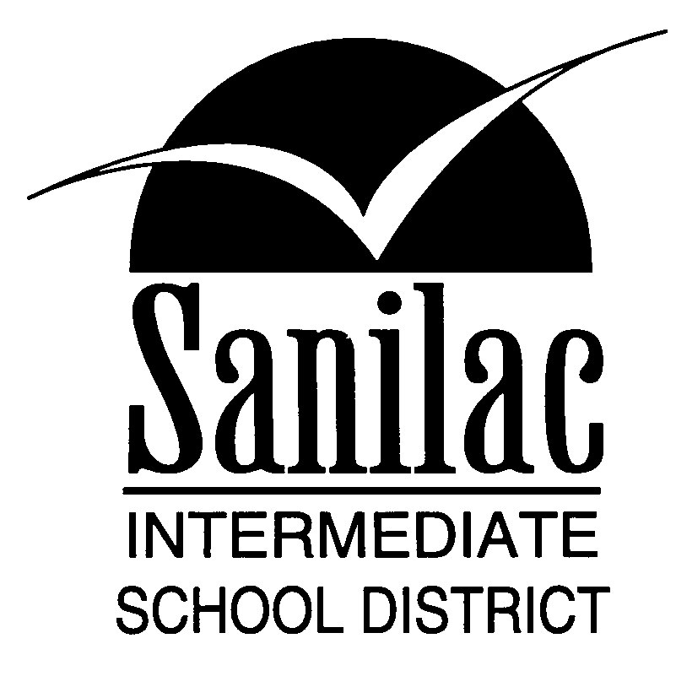
Special Education Services
46 North Jackson Street
Sandusky, Michigan 48471
810-648-2200

SUPPORT STAFF REPORT

STUDENT:

______________________________________________

Please respond to the following questions as they pertain to this student:

(KEY: 1 = GOOD 2 = ACCEPTABLE 3 = NEEDS IMPROVEMENT)

Class work 1 2 3

Tests 1 2 3

Basic Skills 1 2 3

Assignments 1 2 3

Attitude/Conduct 1 2 3

Work Habits 1 2 3

Participation 1 2 3

Behavior 1 2 3

Grade at this time:

Comments: ________________________________________________________________________________________________________________________________________________________________________________________________________________________________________________________________________________________________________________________

Name of Support Staff completing this form: ________________________________________
Position: ____________________________ Date: ________________________________

Name of student’s General Education Teacher: _______________________________________
*Keep a copy of the completed form for your files!

Please return this report to the student’s general education teacher. Thank you for your input.

